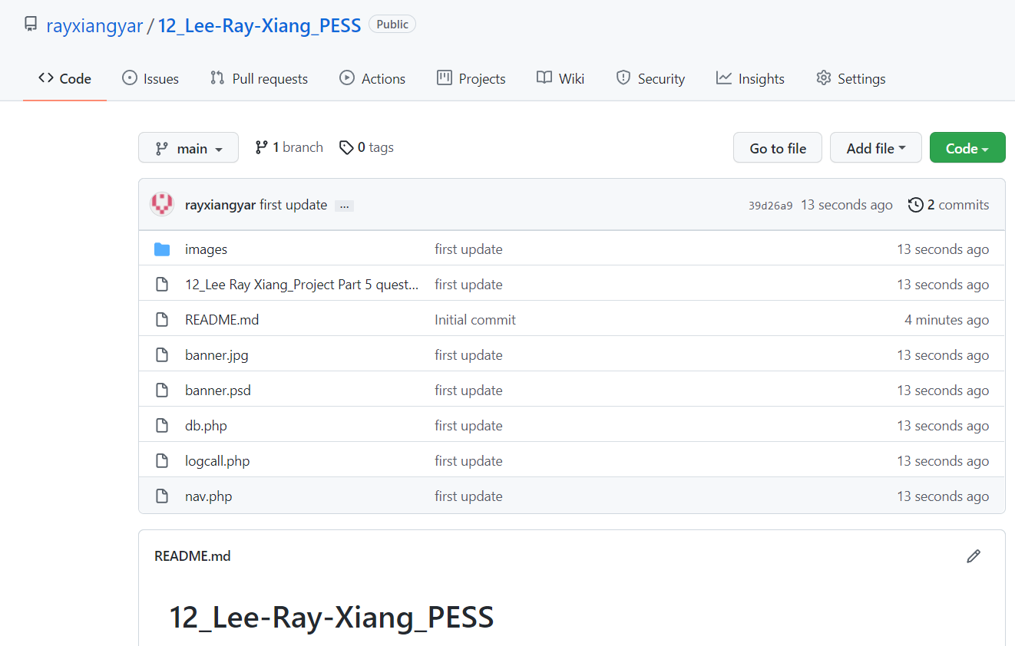

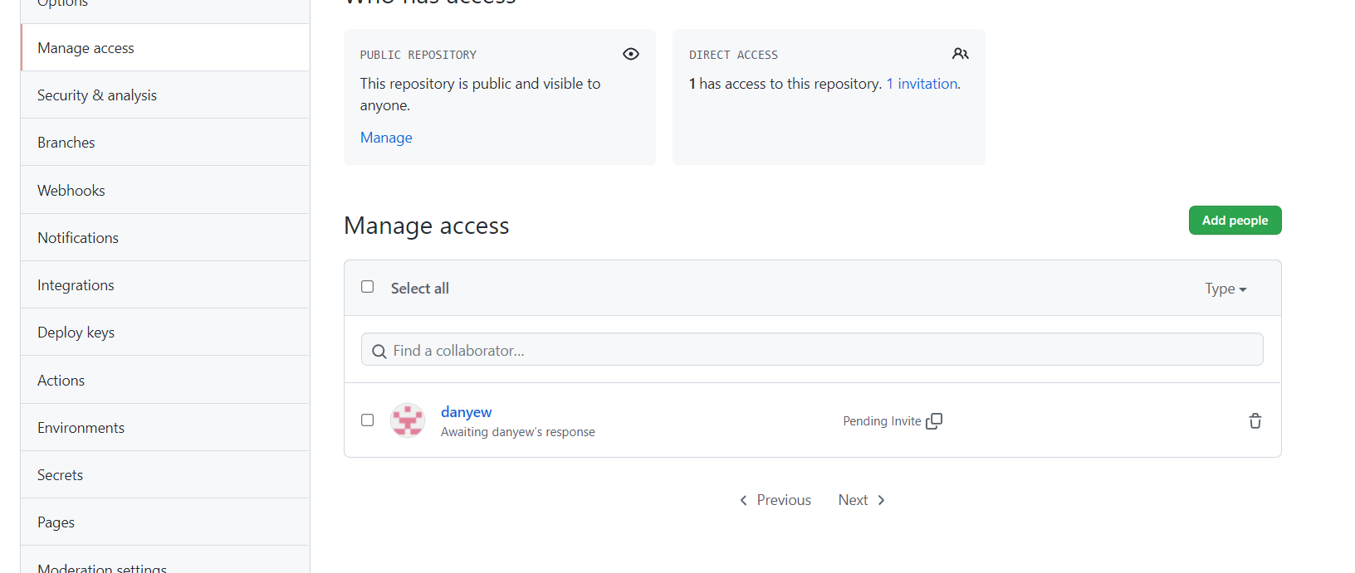

<https://github.com/rayxiangyar/12_Lee-Ray-Xiang_PESS.git>